Ai Lab task 05

Name: Hanzla Ashraf
Roll no: 353

- Trace the supplied tree by hand u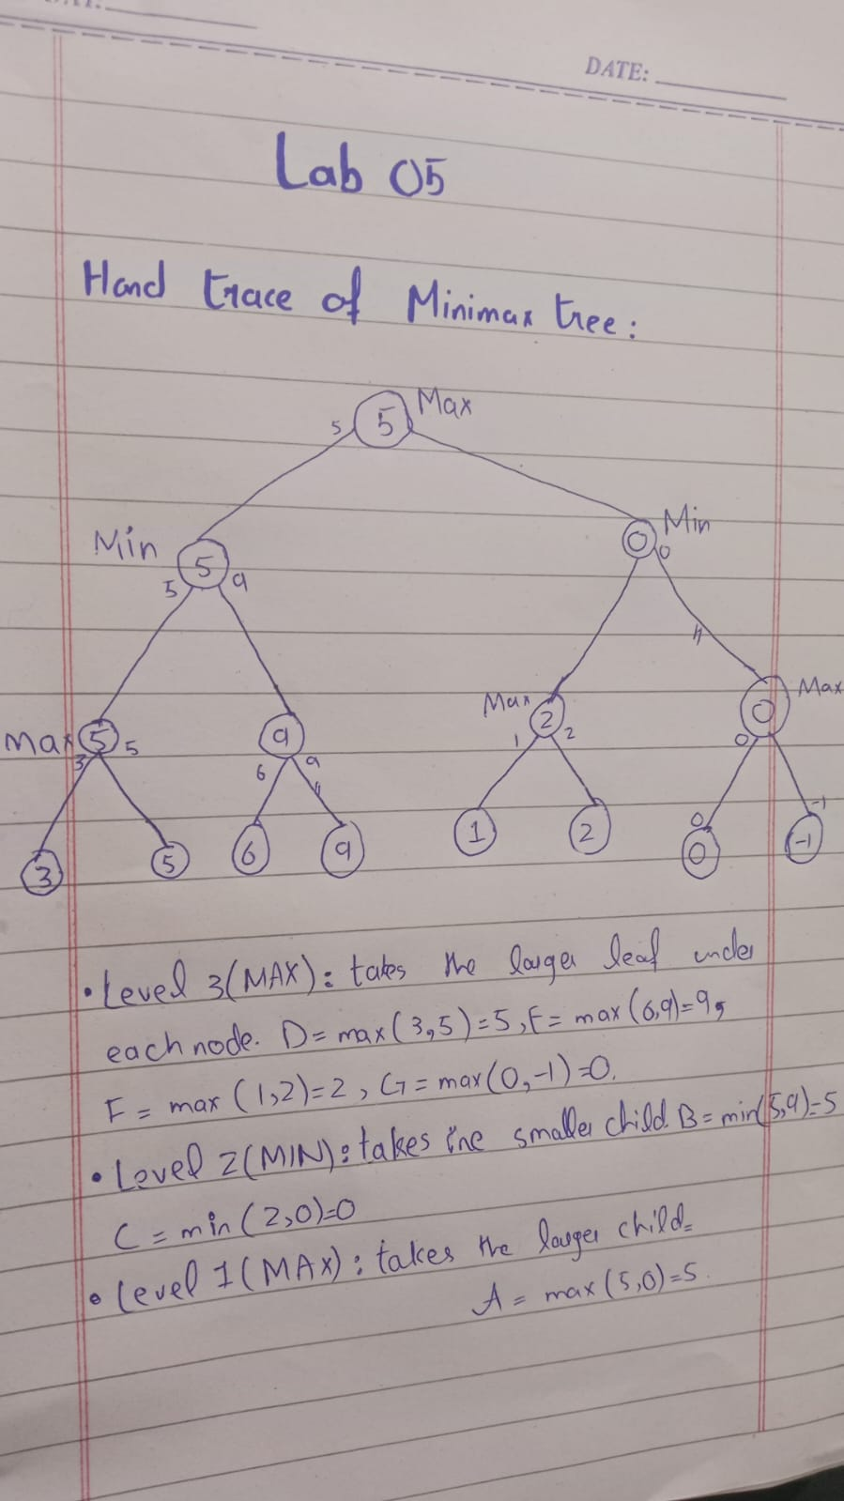

Task 2 & 3:
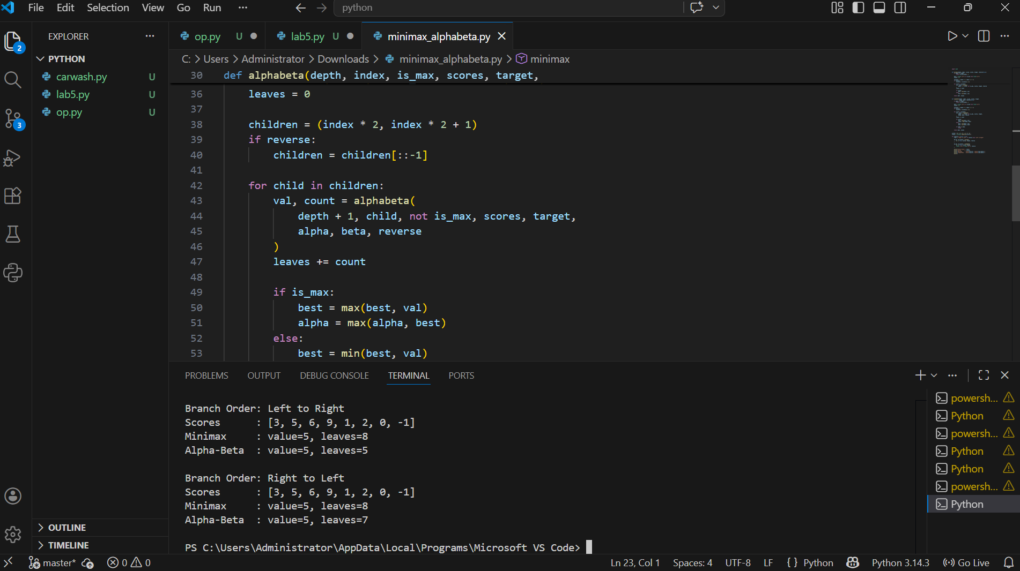

Order type | Scores list | Root values | Minimax leaves | Alpha-Beta leaves
Normal(left to right) | [3, 5, 6, 9, 1, 2, 0, -1] | 5 | 8 | 6
Best order | [9, 6, 5, 3, 2, 1, 0, -1] | 5 | 8 | 5
Worst order | [1, 2, 0, -1, 3, 5, 6, 9] | 5 | 8 | 8
Equal | [5, 5, 5, 5, 5, 5, 5, 5] | 5 | 8 | 5

Short Explanation & Edge Case
- Explanation: Minimax and Alpha-Beta both arrive at the exact same outcome (5 at the root). The fundamental difference is that Minimax exhaustively inspects all 8 leaves regardless of the context, whereas Alpha-Beta tracks bounding values and bypasses redundant subtrees whenever α≥β\alpha \ge \betaα≥β, resulting in fewer leaf evaluations under normal conditions.
- Reordering: When arranged in Best Order, favorable branches are evaluated upfront. This allows Alpha-Beta to tighten its boundaries immediately and skip substantial portions of the tree, evaluating just 5 leaves. Conversely, in Worst Order, the sequence prevents early cutoffs, forcing Alpha-Beta to check all 8 leaves just like standard Minimax.
- Edge Case: When every leaf score is identical ([5, 5, 5, 5, 5, 5, 5, 5]), the uniform values quickly satisfy the pruning condition, allowing Alpha-Beta to bypass unnecessary checks and evaluate only 5 leaves.

Reflection
1. What did you learn today?
How Minimax exhaustively searches the entire game tree to find the optimal value, and how Alpha-Beta pruning optimizes this process by cutting off useless branches without altering the final outcome.
2. How will you apply this in a real AI system?
In turn-based adversarial games like Chess, Checkers, or Tic-Tac-Toe to evaluate future board states and make optimal moves much faster.
3. What failed or surprised you?
Changing the branch ordering drastically impacted the efficiency of Alpha-Beta pruning (reducing checked leaves from 8 down to 5) while keeping the final root value entirely identical.
4. What would you do differently next time?
Test the algorithms on a larger, deeper game tree (e.g., depth 4 or 5) to observe exponential performance differences in leaf evaluations.

